CUSTOM CONTROLS

SoftKeyTextCtrl:
This control is an instrument soft-key with editable text area. It should exhibit the following behavior:
- On clicking the control the editable text area should open to the left. To close the editable text area the control should be clicked again.
- The editable text area should only accept the float / double / integer values.
- When the editable text area is closed the soft-key value should be equal to the edited value. Also, the soft-key value should display proper units, like Hz, KHz, sec, etc.
- The name of the editable area is same as the soft-key name.
- The value of the soft-key is shown within braces.
- The editable text area closes when-ever the soft-key losses focus.

SoftKeyComboCtrl:
This control is an instrument soft-key with combo-box. It should exhibit the following behavior:
- On clicking the control a combo-box should open to the left.
- The combo-box closes under following conditions:
  - When the soft-key is clicked again
  - When any of the value in combo list is selected by mouse click
  - When the picture on the combo-box is clicked
  - When the text area of the combo-box is clicked
- When any of the value in combo list is selected:
  - Text of the combo-box should be equal to the selected value
  - The value of the soft-key should be equal to the selected value
  - The combo-box should close
- The value of the soft-key is shown within braces.
- The combo-box closes when-ever the soft-key losses focus.

DualStateSFKCtrl:
This control is an instrument soft-key with dual state values. It should exhibit the following behavior:
- The soft-key shows two possible values.
- The current selected value is in bold font.
- On clicking the soft-key the selected value toggles between the two possible values.
PictorialComboBox:
This control is a custom combo-box, for Win CE, with an option for selection of picture. It should exhibit the following behavior:
- Allows the user to change the picture in the combo-box.
- On clicking the control the combo list drops down. If the drop-down crosses the parent control boundary the combo-list raises-up.
- On selection of any item the text of the combo-box changes accordingly.
- The combo-box closes when the item selected in the list is same as the text in the combo-box or the picture is clicked again.

GroupBox:
This control is a custom group-box, for Win CE. It should exhibit the following behavior:
- Change the name of the group-box. On changing the name of the group-box the length of the broken portion of the rectangle in the group-box is adjustable.
- The group-box allows controls to be added into it. For this, AddOverlapping controls property needs to be set. This property should only be set after the initialization of the form that is using this group-box. During design this property must not be changed and should be false.

NAVIGATION MECHANISM:

- The rules being followed for Navigating through Controls in the Config screens are as follows:
- Navigating Down or Up in a column takes you to the next column or previous column when there is no element remaining in that particular Column
- Navigating Right or Left in a Row takes you the Next or Previous Row when there is no element remaining in that row.

- Each Config Screen has its own Navigation Matrix defined which determines which Control on that Config Screen lies in which row or Column for Navigation
- Keyboard shortcuts for Navigation are:
- “Alt + Down Arrow Key” for moving Down
- “Alt + Up Arrow Key” for moving Up
- “Alt + Right Arrow Key” for moving Right
- “Alt + Left Arrow Key” for moving Left

CONFIGURATION DIALOGUES :

General Pattern for all Configuration Dialogs:

- Soft key 1 : Source Key
- Soft key 2 : Configuration Key ( Generates Configuration Dialogs)
- Remaining Soft keys : Accelerators (Shortcuts to changing Frequently used parameters in the Configuration Screens)

Frequency Screen:

This screen provides the various frequency setting and also allows changing them.
- The frequency configuration page appears on pressing “Alt + F” key on the keyboard.
- The frequency accelerators allow changing the frequency parameters directly. When any of the frequency parameter is changed via the accelerator then other frequency parameters changes accordingly.
- Various custom controls used in this frequency screen should exhibit their individual behavior as above.

ConfigureFrequencyCtrl:
This user control provides frequency configuration dialogue. It should exhibit the following behavior:
- The frequency configuration dialogue appears on pressing the “Configure Frequency…” soft-key.
- Provides option for editing following frequency parameters:
  - Start
  - Stop
  - Span
  - Centre
  - Total Time
  - Delta Frequency
- On changing any of the above frequency parameter values, the other frequency parameters should adjust automatically.
- On pressing the Ok button the frequency configuration dialogue should close and the changes made in the frequency parameters should reflect on the corresponding accelerators.
- Various custom controls used in this frequency configuration dialogue should exhibit their individual behavior as above.

Channel Screen:

This screen provides the various channel setting and also allows changing them.
- The channel configuration page appears on pressing “Alt + C” key on the keyboard.
- The channel accelerators allow changing the channel parameters directly.
- Various custom controls used in this channel screen should exhibit their individual behavior as above.
- Soft Key 1: “Working Channel”; we can select the Working Channel from a Combo Box; and the remaining Soft key Accelerators should get refreshed showing the Channel settings for that particular Channel. There are four working Channels :
- 1
- 2
- 3
- 4

Possible Test Steps:
- Change Working Channel to 1 and Change the Remaining Accelerator Parameters values like Voltage Range to “+1”, Window to “Blackman Harris”
- Now Change the Working Channel to a different Channel, say 3 and again change the Voltage Range to “+2” and Window to “Hamming” parameter values of the Accelerators.
- Now Changing the Working Channel back to Channel 1 should reflect the values “+1” and “Blackmann” for Voltage Range and Window respectively.
- On Clicking Soft key 2: Configure Channel you should be able to view the same parameters for Working Channel1 in the Voltage Range and Window Combo Boxes.

- Soft key 2: “Configure Channel...” The Configure Channel screen should appear showing Channel Parameters for the particular Channel selected through Soft key 1.
- Soft key 3: “Window” is used to change the Window Type of the Working Channel from a Combo Box and save the settings in Instrument Proxy.
- Soft Key 4: “Coupling” is used to change the Coupling Type from a Dual state Accelerator Type .Clicking should toggle the value between “AC” and “DC” and set the selected value in the Instrument Proxy.
- Soft Key 5: “Weight Filter” is used to Change the Filter Type from a Combo Box and set the selected Value in Instrument Proxy.
- Soft Key 6: “Voltage Range” is used to change the Voltage Range from a Combo Box and set the selected value in the Instrument Proxy.
- Soft Key 7: “Active Ref Channel” is used to Change the Active Ref Channel for the System. This parameter does not appear in the Configure Channel Screen.
Possible Test Steps:
    - Change Active Ref Channel to “Channel 3”
    - Go to Meas Data (Alt+D)
    - Select “Cross Power Spectrum” from SoftKey 1- “Meas Data Type” combo box
    - The Denominators for the Soft keys 4 to 7 Should be Ch3 (See figure below)
    - Do steps a) to d) for all values of Active Ref Channel.

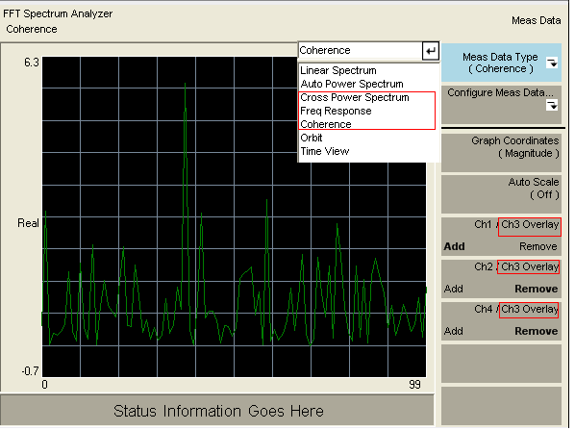

ConfigureChannelCtrl:

This user control provides the channel configuration dialogue. It should exhibit the following behavior:
- The channel configuration page appears on pressing the “Alt + C” key on the keyboard.
- The channel configuration dialogue appears on pressing the “Configure Channel…” soft-key.
- Provides option for setting various channel parameters:
  - Window
  - Coupling
  - Voltage Range
  - Weight Filter
  - Force Exponential settings:
    - Force Width
    - Exponential Decay

- When the selected window type is “Force Exponential”, the Force Exponential group-box is enabled and the Force Exponential settings are editable.
- On all other values of Window the Force Exponential Group Box is non editable and non Navigatable.
- The Working Channel Text Box on the top of the Screen is disabled and cannot be enabled or navigated through in any way. It indicated the Working Channel whose parameters are being modified through the Config Channel screen.
- On pressing the Ok button the channel configuration dialogue should close and the changes made in the channel parameters should reflect on the corresponding accelerators for the Particular Working Channel; for which the Changes were made (which is the selected Channel in Soft key 1).
- On Pressing the Cancel Button the changes made to Channel settings will not be saved in the Instrument Proxy and Accelerators that come up will not reflect the Changes made.
- Various custom controls used in this channel configuration dialogue should exhibit their individual behavior as above.
- The Fields with the picture next to them are the ones that can be edited as a shortcut through the Accelerator Soft keys ( i.e. all Soft keys after the Soft Key 2)

Header and Status Bar Control

These controls are to provide status or different header messages while operating the front panel. Header bar is always on the top of screen and Status bar is on the bottom side. These bars can be divided into 3, 4 or 6 divisions as per the requirement and have messages at different sections.
For example header bar shows the menu page title of current node, the measurement mode and other.
Currently it is exhibiting following behavior:
- On Start up, the header bar will show the current page name “Analyzer Type” on upper right hand side.

- On pressing “ALT + F”, it will show “Freq. /Time” on upper right hand side.

- On pressing “ALT + C”, it will show “Channel Setup” on upper right hand side.

- Currently mode Status will not be changed and will be constant to FFT Spectrum on left upper part, as changing mode is not implemented yet.

DisplayLayout
On pressing “ALT + L”, Front Panel Shows Display Soft Keys and header bar will show “Display Layout”

Soft Key “No of Display” divides display in selected parts.
Soft Key “Status” will show or hide Status Bar
Soft Key “SoftKeys” will show hide Soft Keys. And also on pressing any other key will
make soft keys visible.
Soft Key “Meas Graph” will make Graph mode to full.
Soft Key “Configure Layout” will give you two options in combo box.
1. Load PreConfigured
2. No of display

LoadPreConfiguredCtrl: This user control provides you dialog for pre-configuration of graph. But on selection the behavior is not implemented yet.

NoOfDisplayCtrl: This user control provides you dialog for configuring the layout or making selection for no of displays on graph. On pressing “OK” the graph will change its layout as per selection.

After selection, Pressing “ALT + G” will change the active graph on screen, if there is more than one graph.

Trigger

On pressing “ALT + T”, Front Panel Shows Trigger Soft Keys and header bar will show “Triggering”

Soft Key “Trigger Type” is used to select trigger type from combo box and save the
setting in Instrument Proxy.
Soft Key “Slope” will make decision for slope with dual state accelerator and save the
setting in Instrument Proxy.
Soft Key “Level” is used to mention level and save the setting in Instrument Proxy.
Soft Key “Slope” is used to make External filter On or Off and save the setting in
InstrumentProxy.
Soft Key “Delay” is used to mention delay and save the setting in Instrument Proxy.

Soft Key “Configure Trigger” will provide the Trigger configuration dialogue. It should
exhibit the following behavior:
- Provides option for setting various trigger parameters:
  - Trigger Type
Trigger Type “External” will enable External settings to edit.
Trigger Type “Channel” will enable Channel settings to edit.

  - Trigger External Setting
    - Level
    - Range
    - Slope
    - External Filter

  - Trigger Channel Setting
    - Channel No
    - Slope
    - Trigger Level
    - Delay
    - Trigger Level %

“Advance button” will load dialog for configuration ARM, which provide you options for setting ARM parameters.

- ARM Type
ARM Type “RPM” will enable RPM settings to edit.
ARM Type “Time” will enable Time step settings to edit.

- Time Step
- RPM
    - Mode
    - RPM Step Size
    - Slope
    - Level
    - Hold Off
    - Range
    - Pulses per revolution

On Ok, ARM configures dialog will save ARM settings to instrument proxy and back to Configure trigger dialog.
On Cancel, ARM configure dialog will not save ARM settings and back to Configure trigger dialog.
On Ok, Trigger configures dialog will save Trigger settings to instrument proxy and back to Graph.
On Cancel, Trigger configure dialog will not save Trigger settings and back to Graph.

On again opening of configure screen, it will up with saved settings.
MeasValue Test Cases:

Alt+V combination shows the MeasValue screen.
The header bar shows the heading “Measured Possible Values” on the extreme right.

- One Display with Single Channel Added
  - Test for Show/Hide options of all the MeasValue types and fundamental frequency by pressing the soft-keys.
  - The source key shows only one channel in the list not all the channels; rest of the list is empty.
  - Now select every options of the configure key one by one and change the different parameters in the configure window.
  - For every MeasValue type, test by keeping the value of various parameters different and then same. Check for the values by revisiting the configure windows.
  - Perform the above test and check for the values by visiting different screens and then revisiting the MeasValue screen. This test is basically to check if the value of different parameters in the MeasValue types is stored and does exists when one revisits the MeasValue by configuring other screens.
  - For the THD MeasValue type, when the fundamental frequency is changed in the configure window then the corresponding change is reflected in the status bar if the fundamental frequency is enabled to be shown.
  - Test by using the keyboard shortcuts, Alt+F1/Alt+F2, etc, for the soft keys.
  - Test the Keyboard navigation inside the configure windows bye using the Alt and different arrow keys. The navigation should be in the direction of arrow keys.
Alt+D combination shows the MeasData screen, in which you can Add/Remove channels to the currently active display control.
Use Alt+D combination and add different channel one at a time, always keep the single channel added to the display and perform above tests (a - h). Try with different sequences of adding and removing the channels to check if the parameter values configured for different channels retain (is stored or not).

- One Display with Two Channels Added
Alt+D combination shows the MeasData screen, in which you can Add/Remove channels to the currently active display control.
Use Alt+D combination and add Channel 2.
- The source key should show two channels in the list.
- Perform tests (b – h) in test case 1.
- Try with different values of all the parameters in each MeasValue type for both the selected channels.
- Perform above tests with different combinations of channel types and different values of parameters in each MeasValue types.
- The frequency value displayed in status bar is always equal to the value of Fundamental Frequency selected for the THD MeasValue type for the currently active trace/channel.

- One Display with Three Channels Added
Alt+D combination shows the MeasData screen, in which you can Add/Remove channels to the currently active display control.
Use Alt+D combination and add Channel 2 and Channel 3
- The source key should show three channels in the list.
- Perform tests (b – h) in test case 1.
- Perform tests (c – e) in the test case 2.

- One Display with Four/All Channels Added
Alt+D combination shows the MeasData screen, in which you can Add/Remove channels to the currently active display control.
Use Alt+D combination and add Channel 2, Channel 3 and Channel 4.
- The source key should show four channels in the list.
- Perform tests (b – h) in test case 1.
- Perform tests (c – e) in the test case 2.

- Two/Three/Four displays with Single Channel Added.
Use Alt+L combination to change the number of displays from Single to Two/Three/Four. By default only channel 1 is added to both the displays. This test will check if the settings saved for same channel added in multiple displays are saved uniquely for that display or not. Use Alt+G combination to change the active display in a serially, that is from channel 1 to 2 to 3 to 4 and then again to 1 and so on.
  - Initially starting with two displays and only channel 1 added to both the displays.
  - Configure different parameters of all the MeasValue types with diplay 1 active and channel 1 added to it.
  - Check if the value of all the MeasValue type parameters is saved, by revisiting the different MeasValue types again and again for active display 1 and channel added 1.
  - Toggle the active display from 1 to 2.
  - Perform steps b and c again, now with active display 2 and channel added 1.
  - After this randomly select the active display and check if the configured values are saved correctly or not.
  - Check if the value of fundamental frequency and other displayed parameters is changed accordingly with the change in active display.
  - Perform tests (a to g) with number of display three and then four but every time same channel added to all the displays, that is either channel 1, channel 2, channel 3 or channel 4. Check if the configured value is saved each time.
  - Perform above tests with random selection of number of displays added; the active trace and the channel added to each display, keeping the added channel same in every display.
  - Check if the configured settings are saved even on adding the new display or removing the existing displays from the system.

- One Display with Two/Three/Four Channels Added
Use Alt+L combination to change the number of displays to Single and use Alt+D combination to add the required number of traces (Two/Three/Four) to the display. This test will check if the settings saved for different channels added in a display are saved uniquely for each added channel or not.
- Initially start will two channel/traces added to the display. Say for example, channel 1 and channel 2 are added to display 1.
- Configure different parameters of all the MeasValue types, with channel 1 / trace 1 set active.
- Next configure all the parameters for each MeasValue type, with channel 2 / trace 2 set active.
- Now, set channel 1 as active again and check for the earlier saved values. Similarly check for the values set for channel 2.
- Randomly revisit different MeasValue screens for each channel made active one-by-one to check for the correctness of saved parameters.
- Perform steps (a – e) with different combinations of channels and different number of channels added.

- Two/Three/Four displays with same number and same type of channels added.
Use Alt+L combination to change the number of displays to Two/Three/Four and use Alt+D combination to add the required number of traces (Two/Three/Four) to the displays. Use Alt+G combination to traverse through the displays or set them active in a serial manner. This test will check if the settings saved for same channels (two or more) added in different displays are saved uniquely for each display or not.
- Initially start with two channels added to two displays. Say for example, channel 1 and channel 2 both are added to two displays, display 1 and display 2.
- Configure different parameters of all the MeasValue types, with channel 1 and channel 2 set active one-by-one for display 1.
- Similarly configure different parameters of all the MeasValue types, with channel 1 and channel 2 set active one-by-one for display 2.
- Check for the saved value of various parameters in all the MeasValue types by revisiting different MeasValue screens in a random manner. The parameter values should be as saved earlier.
- Perform steps (a – d) with more channels added to the displays 1 and 2.
- Perform above test with different number of displays (three/four) and different number of channels (two/three/four) added, keeping same the number and type of channels added in each display.

- Two/Three/Four displays with different number of different type of channels added.
Use Alt+L combination to change the number of displays to Two/Three/Four and use Alt+D combination to add the required number of traces (Two/Three/Four) to the displays. Use Alt+G combination to traverse through the displays or set them active in a serial manner. This test will check if the settings saved for different channels added in different displays are saved uniquely for each display or not. This test considers the random combination of added channel types, number of channels and number of displays.
- Perform the test sequences in Test Case 7 with the random selection of added channel numbers and channel types in different displays (two/three/four).

Averaging Screen

This screen provides the various Averaging settings and also allows changing them.
- The Averaging configuration page appears on pressing “Alt + W” key on the keyboard.
- The Averaging accelerators allow changing the Averaging parameters directly.
- Various custom controls used in this Averaging screen should exhibit their individual behavior as above.
- Soft Key 1: There is no Source/Soft Key 1 Key for The Averaging Screen.
- Soft Key 2: “Average Type” is used to change the Average Type from a Combo Box and save the settings in the Aml.
- Soft Key 3: “Average On/Off” is used Enable or Disable Averaging for the System. Clicking on the this Soft key should toggle the value from between “On” and “Off”
- Soft Key 4: “Number of Averages” is used to set the Count of Samples for Which Averaging is to be calculated. It is a Text Control whose value can be changed through the Keyboard.
- Soft Key 5: “Repeat” is used Enable or Disable Repeat for The System. Clicking on this Soft key should toggle the value from between “On” and “Off”.
- Soft Key 6: “Overload Reject” is used to Enable or Disable Overload Rejection for the System. Clicking on the Soft key should toggle the value from between “On” and “Off”.
- Soft Key 7 and Soft Key 8: “Accept preview” and “Reject Preview” are disabled by Default and cannot be clicked. They are enabled when Preview is enabled in the Configure Average Screen. (Explained in Detail Later)

Possible Test Cases on Switching Averaging –“On”:

Averaging can be switched “On” in two ways:
- By Clicking Soft Key 3 “Average On/Off” Soft Key.
- Selecting “On” in the “Average On/Off” Combo Box in the “Configure Average…” Screen and Clicking “Ok Button” also sets the Averaging to “On” for the System.

When Averaging is Switched On through “Average On/Off” Soft Key:

- The Status Bar at the Bottom Center of The Screen should start showing the Updated Averaging Count starting from 1 to the Number of Averages selected through the “Number of Averages” Soft key 4.(See Figure Below)
- For Example if The Number of Averages is set to the Default 5 then the display at the Bottom should be Counting From Avg : 1 to Avg : 5 and Back.
- Change the Number of Averages to say 15 in Soft key 4 and the Count should now start counting to 15.
- Click on Soft key 3 and Switch off Averaging.
- The Avg Count Label should disappear from the Status Bar

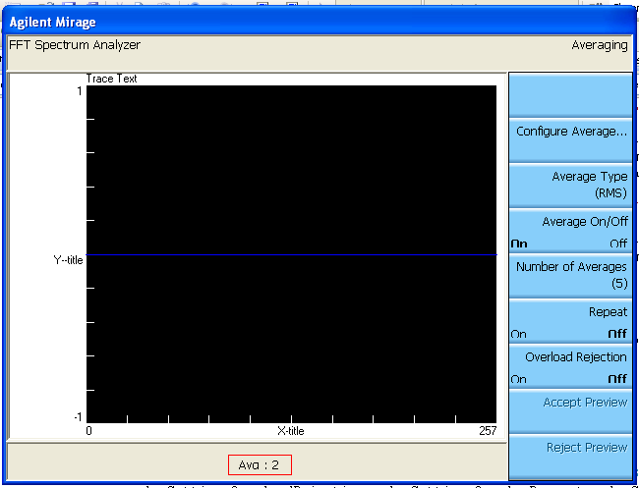

ConfigureAverageCtrl:

This user control provides the Average configuration dialogue. It should exhibit the following behavior:
- The Average configuration page appears on pressing the “Alt + W” key on the keyboard.
- The channel configuration dialogue appears on pressing the “Configure Average …” soft-key.
- Provides option for setting various channel parameters:
  - Type
  - Average On/Off
  - Number of Averages
  - Repeat
  - Overlap%
  - Overload Reject
  - Fast Average
  - Update Rate
  - Preview Group Box:
        - Type
        - Preview On/Off
        - Time (If Preview Type is “Time”)

- When the selected “Average On/Off” combo Box value is “On” :
Possible Test Steps:
  - Click “Ok Button”.
- The Status Bar at the Bottom Center of The Screen should start showing the Updated Averaging Count starting from 1 to the Number of Averages selected through the “Number of Averages” Soft key 4.
- For Example if The Number of Averages is set to the Default 5 then the display at the Bottom should be Counting From Avg : 1 to Avg : 5 and again Repeat count from 1 to 5 and so on. ( Repeat behavior is tentative , may be changed later)
- Click on the “Configure Average ...”( Soft key2 )
- Change the Number of Averages to say 15 in “Number of Averages” Text Box and the Count should now start counting to 15.
- Click on “Ok Button”.
- The Status Bar at the Bottom Center of The Screen should now start counting to 15.
- Click on the “Configure Average ...”( Soft key2 )
- Selected “Average On/Off” combo Box value to “Off”.
- Click on “Ok Button”.
- The Avg Count Label should disappear from the Status Bar

- When the selected “Preview type” combo Box value is “Time”, the Time Text Box becomes visible and is editable.(See Figure Below)
- When the selected Preview type is “Manual”, the Time Text Box becomes invisible.
- When the selected “Preview On/Off” combo Box value is “On”, Soft Keys 7 and 8: “Accept Preview” and “Reject Preview” become enabled. (See Figure Below )

Possible Test Steps:
- Select “Preview On/Off” Combo Box to “On”.
- Click on “Ok” button.
- Soft Keys 7 and 8: “Accept Preview” and “Reject Preview” become enabled. (Clicking on them does not do any action yet)
- Again Click on “Configure Average...” Soft Key 2
- Select “Preview On/Off” Combo Box to “Off”.
- Click on “Ok” button.
- Soft Keys 7 and 8: “Accept Preview” and “Reject Preview” become disabled.

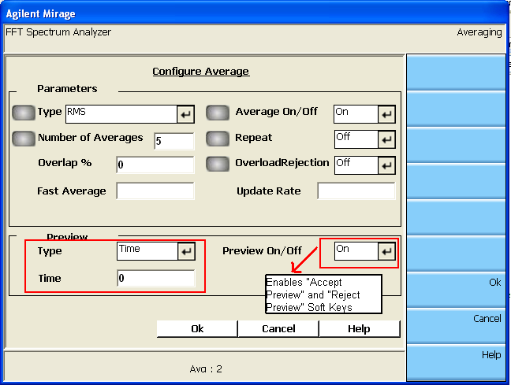

- The Fast Average and Update Rate on the top of the Screen is disabled and cannot be enabled or navigated through in any way. They have not been implemented.
- On pressing the Ok button the channel configuration dialogue should close and the changes made in the Averaging parameters should reflect on the corresponding accelerators.
- The Fields with the picture next to them are the ones that can be edited as a shortcut through the Accelerator Soft keys ( i.e. all Soft keys after the Soft Key 2)
- On Pressing the Cancel Button the changes made to Channel settings will not be saved in the Instrument Proxy and Accelerators that come up will not reflect the Changes made.
- Various custom controls used in this channel configuration dialogue should exhibit their individual behavior as above.

Measurement Data

On pressing “ALT + D”, Front Panel Shows Display Soft Keys and header bar will show “Measurement Data”. If the Linear Spectrum is in Normal mode then following soft keys will be there.

Soft Key “Meas Data Type” is used to select the type of Measurement Data sent from AML. The content of accelerator keys depend on Measurement Data Types available through AML and the contents of this softkey may vary depending on licence and features sold to a customer. A full featured device will have following options in “Meas Data Type” softkey.

- Linear Spectrum
- Auto Power Spectrum
- Cross Power Spectrum
- Freq Response
- Coherence
- Orbit
- Time View

Soft Key “Configure Meas Data” has two options.

- Trace to Graph: Clicking on this option will show a Trace to Graph dialog. Using this user can add or remove channels. User can also specify a logical name for a particular channel. Similar to accelerators for adding or removing channels this dialog also can have 4 control rows for 4 channels or 3 control rows. The heading of this dialog should show “Traces to Graph (Meas data type*)” where “Meas Data Type*” can be any of the option selected from “Meas Data Type” Soft key. Pressing ok on this dialog should Add/remove channels as shown in the dialog and assign names to channels as specified by user in the dialog. Addition/Removal of a channel should also reflect in the Accelerator keys.
- Water Fall Parameters: User can enable/disable waterfall mode from here. The radio buttons for this should also reflect current state of waterfall mode i.e. on or off. Watrfall depth and waterfall angle can be specified thru this dialog. Dialog should show current Waterfall depth and angle. If a user changes these parameters and presses ok then these changes should get reflected in the Active display and Waterfall Specific Soft keys mentioned below.

Accelerator Soft Key “Graph Coordinate” shows a list of all the Graph coordinate types available for a particular Meas Data Type. The availability information is taken from AML. Choosing a particular Graph Coordinate should change the graph coordinates in the active display.

Accelerator Soft Key “Auto Scale” lets a user select auto scale mode that can be one of the following:
- On – Auto scale On
- Off - Auto scale Off
- Up – Auto scale will be done only if magnitude increase, no auto scaling if magnitude decreases.
- Once – Auto scale will be done only once.

Accelerator Soft Keys 3, 4, 5, 6 depend on the option selected from “Meas Data Type”. For options 1, 2, 6 and 7 selected from “Meas Data Type” the accelerator keys 3 to 6 will have Softkeys “Channel 1 Overlay” to “Channel 4 Overlay respectively”.
For option 3, 4 and 5 selected from “Meas Data Type” the aacelerator key 6 should be blank and keys through 3 to 5 should have format “Ch2 / Ch1 Overlay” to “Ch4 / Ch1 Overlay” respectively.
For soft keys having format “Ch# / Ch* overlay” (# and * denote channel number where # <> *) ‘*’ is the Active Reference Channel.

Channels can be added or removed in the current graph by pressing “Channel # Overlay” or (Ch# / Ch# Ovelray) softkeys (Note # denotes channel number 1 to 4). Channels added or removed should be visible in the current graph display.

If user has selected multiple displays then the Meas Data softkeys currently shown are valid for the current active display. Meas Data softkeys are populated according to the values fetched from AML.

If the Linear Spectrum is in Waterfall mode then following soft keys will be there.

Soft Key “Meas Data Type” and Soft Key “Configure Meas Data” will be same as explained above.

Accelerator Soft Key 1 will be “Waterfall Depth”. User can press this to specify numeric value for water fall depth parameter. Changing value here should reflect in active display showing waterfall. Value changed here should also reflect in the Waterfall Parameters Dialog.

Accelerator Soft Key 2 will be “Waterfall Angle”. User can press this to specify numeric value for water fall angle parameter. Changing value here should reflect in active display showing waterfall. Value changed here should also reflect in the Waterfall Parameters Dialog.

